NOMINATION FOR SDG’S WOMAN AMBASSADOR AWARD

BY MS. TINA CHOPRA.

The Most Important Reason of My Smile.

Part –A
Particulars of the Teacher

- Name (in Block Letters) : TINA CHOPRA
- Designation/ Section : PREPRIMARY TEACHER
- Date of Birth : 13.01.1980
- Residential address with Pin Code: A- 82 PRIYADARSHINI VIHAR DELHI 110092.
- Telephone/Mobile Number : 91-9999024512
- Email tinac@ahlconinternational.in
- Academic Qualifications: (Graduation and Above)
Examination Passed | University | Year | % of marks obtained | Subjects

BA PASS  NTT | DELHI UNIVERSITY  ALL INDIA TEACHERS VOCATIONAL COURSE | 2001  2001 | 68%  72% | HUMANITIES  - CHILD PSYCHOLOGY, CHILD CARE AND HEALTH.  - SOCIOLOGY AND GUIDANCE.  - SCHOOL ORGANISATION.  - PRINCIPLES OF EDUCATION.  - EDUCATION PSYCHOLOGY.  - MODERN METHOD OF TEACHING.

- Professional Qualifications / Technological Enhancements :

Name of the Course | Organization | Year | % of marks/ certificates / badges / points
Various Courses | Microsoft Online Courses | 2017 to 2019 | Points- 105405  Badges – 66  Certificates- 34
Successfully completed four professional courses from Courser  - Foundation of Teaching for Learning: Developing Relationships  - Learning to Teach Online  - Disability Inclusion in Education: Building Systems of Support  - Adhd: everyday strategies for elementary students  - Children acquiring literacy naturally  - First year teaching-success from start  - Art and activity: interactive strategies for engaging with art  - Teaching professional course  - Becoming a better teacher  - experiential learning.  - Developing personal socio qualities for creating a safe and healthy environment.  - Curriculum and inclusive classroom.  - Health and well-being in schools.  - Competency based education module 1  - Chd_art integrated learning  - Rise diksha: भाग भिन्न एवं अंदाज़ लगाने कि कौशल  - Aees_preschool education  - Competency- based education- module 2  - Basics of covid  - Cbse_preschool education  - Art and music  - School based assessment. | Coursera  Coursera  Coursera  Coursera  Coursera  Coursera  Coursera  Coursera  *Hindu Step  British Council  Diksha Portal  Diksha Portal  Diksha Portal  Diksha Portal  Diksha Portal  Diksha Portal  Diksha Portal  Diksha Portal  Diksha Portal  Diksha Portal  Diksha Portal  Diksha Portal | 2018-20 | 76%  91.30%  93.75%  100%  87.50%  86.67%  93.7%

- Total Service with date of joining as a teacher (in Ahlcon and before):

Total service: 23 years

Classes being taught: Nursery and Prep

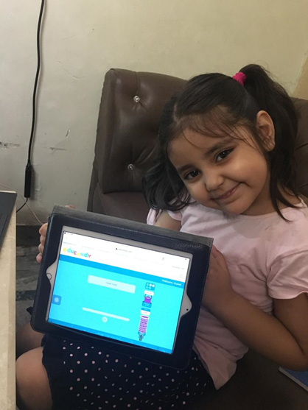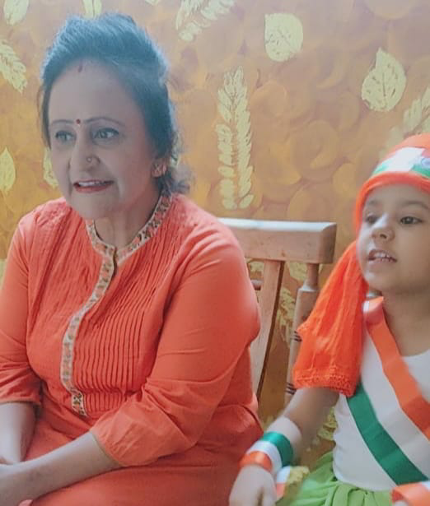

When we think about how students communicate, we often think about how they speak to adults and their peers. The role of teacher is focused on how these young people speak to themselves, i.e, internal dialogue.

Growing up is never easy and spending time with these little creatures and solving their tiny -tiny problems always have us reminiscing back to our childhood.
Never underestimate capabilities of a child, they can do amazing things. We inspire our students to do wonderful things because we know kids bust down the walls when someone pushes, believes, and cares for them. TEACHER COMMUNITY does that and all the students are lucky to have such teachers in their lives.
Educating the mind without educating the heart is no education. Teachers plant seeds that grow forever. So, I am lucky to choose this as my profession.

I am Tina Chopra an Early Childhood Educator; I am passionate and an enthusiastic learner. For me a role of a teacher increases while teaching little kids on virtual platform. When the pandemic started, and we were told to start virtual classes we were in dilemma about the techniques that can be used to teach the toddlers.

My action for happiness is to accept challenges and learn new things, so I started browsing Apps, attended workshops and learned new apps to make my virtual classes more interesting and livelier.

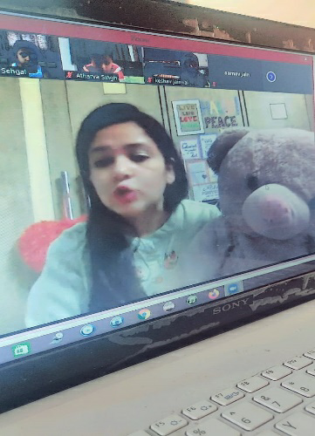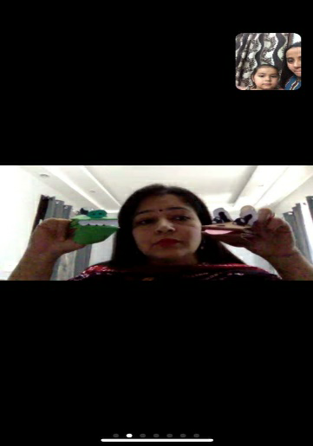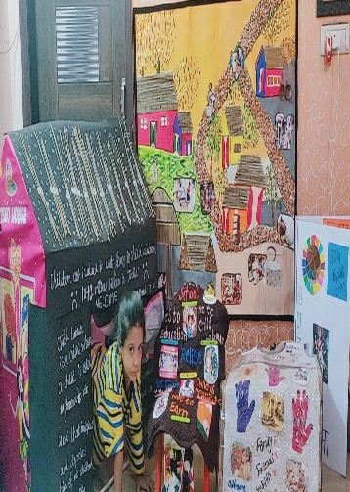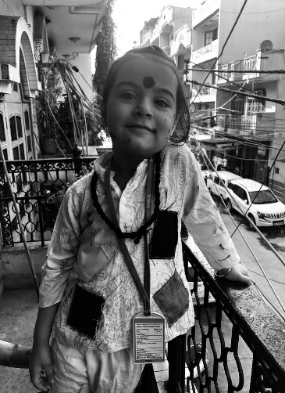

Initially I was not given any particular responsibility but I myself initiated to take various responsibilities in my educators group like decoration of virtual boards, making online flash cards by using various online tools like Quizlet, Buncee etc. Looking at my impressive work I got the opportunity to plan the First Virtual Holiday Homework Display Exhibition, Annual day and Grandparents Day at TEAMS Platform.

I agree with Bill Gates where he says that “Technology is just a tool. In terms of getting the kids working together and motivating them, the teacher is most important.”

I have always taught my students with new methodologies by using realia, flash cards, toys, puppet show etc. During my virtual session I did not leave the zeal to continue my innovations. To settle my class and make my 4-year-old learners my best buddies, I planned online Puppet Shows for my toddlers on the very first day of our online classes. As settled classroom atmosphere becomes the most effective class.

To match up with my curriculum I planned different activities to bring effective methodologies to my teaching. For example: While teaching I adapted inter disciplinary approach, I used new and attractive teaching aids to grab the attention of my learners, I involved my entire class in all the activities held.
I designed my art classes where I taught them to design their own educational toys. Where they made butterflies to string in the thread which helped them to develop the fine motor skills. This was a successful activity which helped children to get engrossed in the constructive way during their free time at home.

- To make my learners aware with the concept of soft and hard, I created a role play with dialogues, where I divided their roles as trees, leaves and flowers. Children were taught to speak lines about their assigned role. They explained about their appearance, importance etc. Children enacted and had a frolic time. At the end, I compiled all the dialogues and converted into a video. I also created different videos by compiling role-plays on various topics like bringing awareness to protect our world, Child labor, quality education, awareness about various festivals.
Links attached:
https://youtu.be/dI5DcZqGwcY

- Young children are the basis for all dimensions of sustainable development. They have a right to thrive, develop to their full potential, and live in a sustainable world. The world should understand that sustainable development challenges are not integrated. Poverty reduction, health, education, agriculture and energy, gender equality and social inclusion, and development within planetary boundaries must be tackled together, and an inter-generational vision of societal development must underlie the goals. Without this vision, there will be no capacity for nations to bring about sustainable development. Keeping this in mind, I, Ms. Tina Chopra formed a team with 9 children of Preprimary section. They participated in SDG Solution Challenge, where they worked on the SDG Goal no. 3 category 3.4 and named my team as ‘Angels the Saviors’. Since these little minds are full of curiosities so to clear their doubts teacher arranged an interview with a well-known wrestler Mr. Deepak Punia who has won silver medal in World Wrestling Championship in 2019 and also secured his place in summer Olympics 2020. They also interviewed the Senior Pediatrician, Dr. Piyush Jain who has 25 years of experience. He had been the former president of Indian Medical Association and now is a president of Indian Association of Pediatricians.
After clearing all doubts all 9 children made posters to spread their words in the social media and made many followers. They also took a pledge to follow the same in future too.

‘Angels the Saviours’ achieved 'SDG Rising Star Inspiration' award in addition to their original certificate.
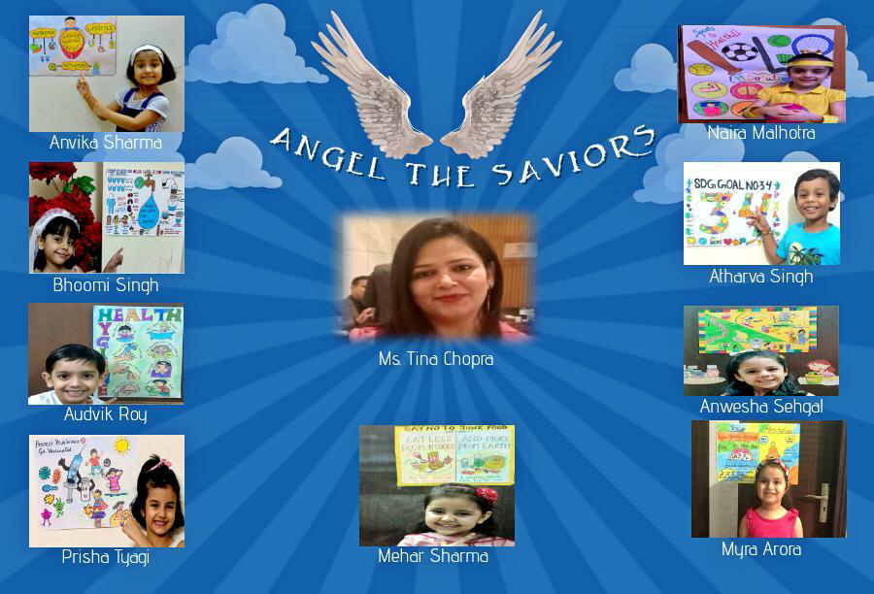
The dedication and enthusiasm of work was recognized by the entire world through the Social Media. Children received appreciation globally. In the zeal of success two of the team members, Myra Arora and Naira Malhotra got an opportunity to be their live speakers where more than 30 countries registered themselves for the biggest ever ‘World Children Conference' held on 22nd August 2020. It was a proud moment when they shared the platform with Director of Ahlcon Group of Schools, Mr. Ashok Kumar Pandey. He was one of the guest speakers in SDG CONFERENCE. His motivational words boosted the morale of all the participants and organizers.
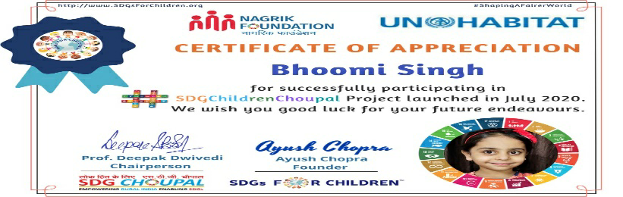
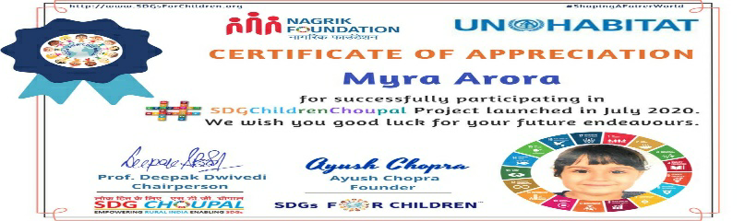

Attending this Conference was a wonderful learning experience as it was a pleasure watching all the children speaking with confidence. Their spirit to work for SDGs is highly appreciable. Both the speakers were delighted to receive certificate of appreciation.

For Reference enclosed please find the link
https://youtu.be/M_BXPtwsHwc

- I always focused upon the conversational skills of my learners, so started with an activity of ‘Mystery Speakers’ during my online classes, where each child drew or pasted the picture of their favorite object. The activity was conducted every Friday where four children from the class got the chance to speak. Mystery was for the audiences (pupil) to guess the object by listening to the lines of the speaker. Cards were shown to all the children only after they guessed the correct object. At the end they got their Buncee Badge with their pictures which they were allowed to set as their profile picture as an award.
In my teaching practice I use different tools to support my teaching techniques, for example: I use smart board, hand puppets, realia for storytelling to improve their audio-visual skills.
I ask them to narrate the stories using same tools. To enhance their language skills.
I appreciated my children to develop reading habits, so I encouraged my children to join the class 15 minutes prior. Early morning, I made a habit to request parents to spread books on their tables randomly where they were asked to read one book before we start our prayer. With regularity of this activity my children improved their reading skills, and they developed the habit of community reading as well. I created my own stories by using various apps like story jumper, platagon, toontastic etc.
LINK
- NAME FUN:
Children were encouraged to write letters A-Z, after this they were encouraged to join them to create their name with it. Later these letters were used to create vocabulary words too.

- STORY SUMS WITH ROLEPLAY:
Story sums were introduced with a roleplay where children were encouraged to become pencil seller and distribute pencils according to the asked pencils. They counted them and distributed equally. Many other situations were also given to explain the concept.

- Physical Exercises:
Regular play and physical activities are an essential part of growth and development in the toddlers. Being active in activities like dancing, running, cycling, jumping, climbing, or playing any game can go a long way in building their muscle strength and increasing their flexibility.
So, activities were planned to incorporate sports with academics. Hopscotch with numbers, Treasure hunt with letters, running jumping hopping while recapitulating oral counting were incorporated in teaching plans. We also celebrated a FIT INDIA WEEK, in our classes which was proved to be a big hit.

List is endless as each festival and activity planned had experiential learning, Art Integration, Sports Integration etc.

There is a better understanding of teacher and a student by providing them with benefits of different teaching aids, no matter whether it is a virtual platform or a physical setup. To develop their listening and speaking skills I always utilized different audio-visual aids for example: Storyjumper, puppets, toys, props etc. The purpose of education at this level is not only giving education. It is to give them deep learning which could be memorized and be helpful to achieve significant perceptual growth.

I always worked for the upliftment of my learners as I believe that growth of these little learners is the growth of our department, school and society as well. I always motivated these learners. I have observed that with my love they work harder to achieve success. Thereby, find a multitude of ways to have bigger impact on others. I love to engage my learners with constructive methods, which help them, grow and glow. I always keep a point to work on introvert children and help them to come out of their cocoon.

THE QUIETEST CHILD OF MY CLASS IS NOW WITNESSED TO BE THE OUTSPOKEN CHILD WHO HAS OUTSHINED ON TWITTER AND OTHER SOCIAL MEDIA TOO. DURING LOCKDOWN SHE WAS FEATURED ON CNN NEWS CHANNEL WITH HER SONG PERFORMANCE.

Discipline in Virtual Class:

I made a habit of demonstrating my classroom as positive classroom by effectively teaching students how to act in different situations. A straightforward way to model certain behaviors is holding a mock conversation within the class by inviting other teacher or student in front of the class. Talking about a test or other relatable topic, so I always made myself sure to use polite language, I always maintain eye contact with my learners and taught them the same technique to use while they interact with someone. I have a policy in my classroom where each child is guided to use placards of ‘May I’ written on it before starting their conversation. This helped me to maintain discipline during the class. I also taught them etiquettes for the same.

They get incentives like stars and smileys in the chat box when they follow all rules in the class. This helps in encouraging children to maintain proper discipline and participate in all the virtual activities.

Sharing is Caring:
It is always a great experience to share our teaching practices. We learn by sharing and improve the educational experience of students as well. To bring innovation in my teaching practice I shared my experiences globally through social media, where I got excellent feedback and motivation to do much better.
I also conducted workshops to enlighten my peers to know about Apps I used to conduct various activities during my virtual sessions.

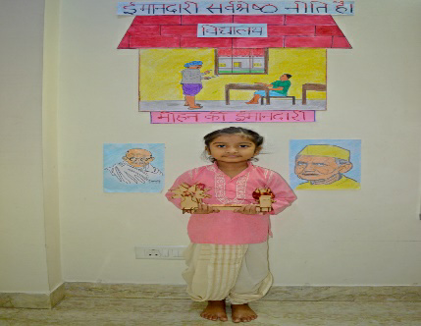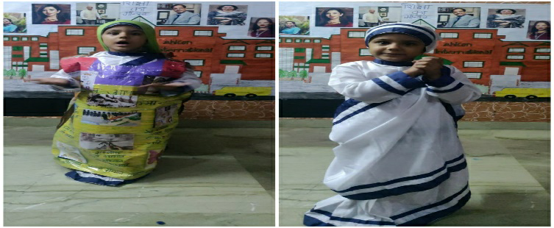
Health and Hygiene:
To create the awareness about health and hygiene I requested all the family members of each student to attend one of the sessions based on the mentioned topic.
I asked them to stand near their child. I asked the person who was standing in right hand corner to paint his/her hand and say hello by shaking hand with the next person, child was shocked, but he smiled and shook hands. Then I asked him to shake hands to the next person and ask how is he doing? They repeated this till they reached to the last family member. Later, I asked them to check their hands. Their hands were painted. Then I explained them this is the way how germs spread by touching so we should always wash our hands. I also added how germs spread by sneezing, coughing etc. At last, I also guided them the correct way of washing their hands and asked them to go to the washroom, follow the method and wash hands at least till 20 seconds.

Need Support
There are few children who require extra support so for them I decided to provide extra time by giving them individual attention. I use Real objects to explain these children about various concepts.
Below are the steps taken for need support children:
- One of the most difficult issues in early childhood is collecting data especially virtually.
- With children who appear to need special assistance as a result of cognitive, emotional, visual, auditory, or motor impairments.
- On one hand, research has demonstrated that early intervention can often reduce or prevent later problems in school.
So, I searched the methods to collect data at preprimary level. Few of them are mentioned below:
- Documenting child’s daily activities to show their initiative and creativity on Buncee App.
- providing an integrated means for evaluating the quality of child’s performance and behavior by making my own spreadsheet.
- reflecting on an individualized approach to pedagogy
- evaluating those elements of learning and development that most conventional assessments
- utilizing the information acquired in the teaching process to further elaborate the evaluative picture of the child that is emerging from the one to one assessment
As an Early Childhood Educators, I rely on some informal monitoring of child learning in order to design programs and plan curriculum to engage in pedagogy.

After keeping a check on all my learners, I found two children of my class who reacted differently for all my queries. I maintained their anecdotes and specially designed programs apart from the curriculum to engage and observe child1 and child2.

I also followed the system to observe, record, evaluate, and document child’s learning. Both the parents were suggested to visit the doctor. One of them followed our suggestions and quickly took an action. Doctor suggested the Occupational Therapy which was proved to be very beneficial.

Meeting with Parents: Piaget developed the “clinical interview” method, which is a most informative technique to assess children’s thinking. The goal of the clinical interview is to identify the child’s underlying processes of thought which is suggested to be taken by trained therapists. Parents submitted the report after meeting with doctor.

Child 1 and Child 2 Case Study were also prepared after notifying changes.

Performance assessment takes different approach to the assessment of competence. It helps in collection of data student wise. It is best understood in the context of learning about child’s knowledge, skills, and accomplishments through observing, recording, and evaluating their performance or work, hence regular check was done on their progress.

Best achievement was to get awesome feedback from parents when they saw their child improving in all spheres.
SDGs ARE IN OUR BLOOD:

Well said by Stacia Tauscher that We always worry about what a child will become tomorrow, yet we forget that he is someone today. I am being an Early Childhood Educator, work for the development and care for the students of this age group.
Development takes place in a series of predictable and common stages: Children become progressively more independent and learn increasingly advanced skills and capacities as they grow older. However, children do develop at different speeds and may reach developmental milestones at different times. What is considered normal child development also varies across cultures and environments, since expectations and parenting strategies may differ not only among countries but also among cultural, ethnic or religious groups within the same country.
Keeping this in mind I took my teaching other way round, I brought innovations by not asking them to answer my questions, but I motivated them to raise questions, I developed them where doors will open for them in places that they could not imagine. I not only just wanted them to become a human but also glorified them to be angels in someone’s life.
With the help of various examples and games I sensitized my children with all the SDGs and brought independence to each child to choose their own specific SDG goal.
I have been encouraging my students to become an angel in someone’s life. Collect things and lay your hand as giver.
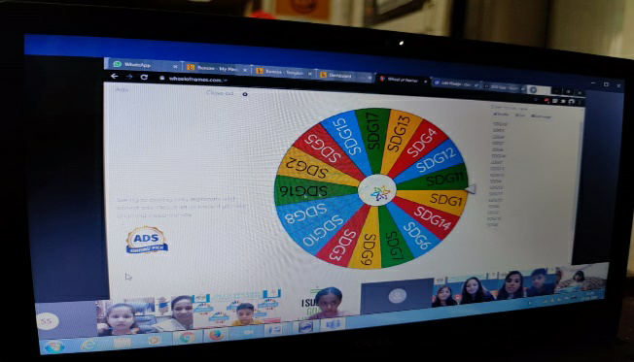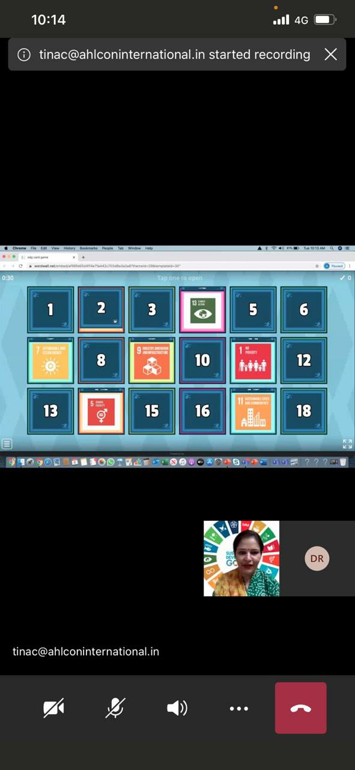
SDG GOAL NO. 1: NO POVERTY

My drive started in the month of April with the first birthday of my class student. He was encouraged to donate food to poor, needy people by taking care of social distancing. Parents were generous and bought dry food packets and distributed in slum area.
I took it further and encouraged to find from their parents if during this pandemic situation any family is facing problem then they can give their helping hand to them. One of my students found a family of his society guard. Due to high rent and low earning, they were homeless, so with his parents help he provided shelter to the family of that guard in their society basement.
Every festival includes the happiness of giving. On Diwali many children distributed blankets, dry food packets and clothes. Few children also donated their books and toys. Children were delighted to celebrate Christmas by becoming Santa for someone who required the most. They bought gifts and distributed them to the needy people.
In my various competitions like Fancy Dress, Recitation, Story Narration I encouraged them to enact by following SDGs, so that they could feel the pain during the enactment and empathize with people and could help them whole heartedly.

SDG NO. 3: GOOD HEALTH AND WELL BEING

I trained my children to take care of their hygiene with various activities like: I organized a puppet show depicting one good girl one bad girl and explained the concept clearly. Mentioned above is the detail work of team, ‘ANGEL THE SAVIORS’.
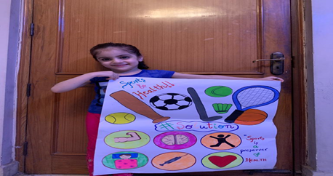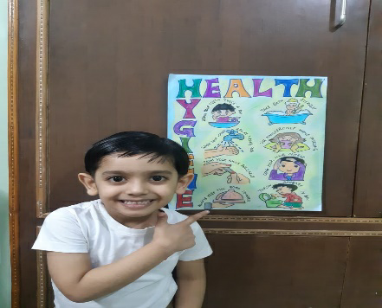

SDG NO. 4 QUALITY EDUCATION

I have taught my children to learn from the daily routine work, which they do. I always encouraged them to spend time with their Grandparents and share it in class during interactive rounds so that other children also get benefitted and encouraged to follow the same practice. I motivate them to help their parents in small household work too.

SDG NO. 15 LIFE ON LAND
I have always taught my children to keep their environment clean, not to waste food or water and not even let others to waste it. I encouraged to water plants with left over water in their bottles. Different activities and videos were shown to protect trees. Online roleplays were also organized to support my teaching.
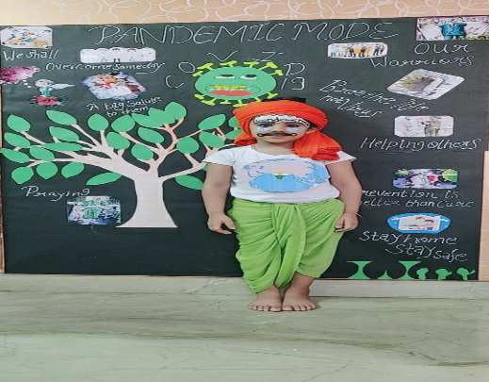

SDG No 2: Zero Hunger

I explained my learners the importance of food and I always asked them to make sure that the food taken should never get wasted. I showed them a video on the same and asked to think and reflect how some people being so blessed never valued things in their life while the others who were less fortunate have to struggle even for a single meal of the day. Since children at this age are unpredictable and do not know how much they can eat, so I also started with the practice of utilizing the leftover food. I encouraged children if they leave any food then they should pack it and serve stray dogs, birds or any animal.

My Efficiencies:

• I am a truly passionate teacher who wants to be an inspiration for others.
• I was able to bring a difference in the life of one of my students in the session 2016-17. It really gave joy when I was able to help a child who was having a hearing problem and was not able to express himself. A smile on his face was of million bucks when he could hear the rhyme and there, I got my reward.
• I always handle my children’s mood swing with ease.
• With patience I always handle the incessant queries and concerns parents have about their child.
• I am creative, I can draw all kind of pictures of relevant themes to make my display boards attractive.
• I use innovative techniques to teach my children and engage them constructively.
• I can manage my class and incorporate lessons through songs, rhymes, role plays etc.
• I am an active listener, and I can gauge the body language of children to understand the emotional condition of children.
• I am a learner by heart, and I keep updating myself by doing different courses which help me to improve my teaching methodologies.
• I am well organized with my work.
• I have excellent relationship with my colleagues.

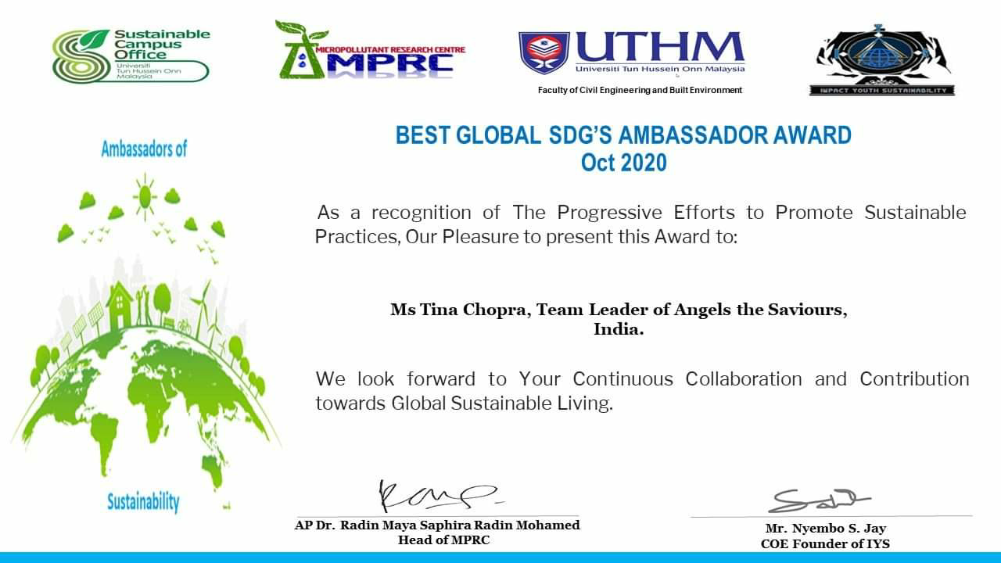

I and my team were invited to share our thoughts on SDG Goal no. 3

Awards and Certifications

*Awarded as Best Class Teacher. (2017)
*Awarded for Best Innovations by Mansha Educational Society (2018)
* Felicitated for successfully completing Action Research (2018)
*Awarded as Exemplary Utilization of Library Resources (2019)
*Rising Star Innovation Award by SDG SOLLUTIONS (2020)

‘There is always something positive to be found in every situation, but it is up to you to find it. Keep your head up and teach happily for the love of education!’

Above mentioned document belongs to Tina Chopra’s one year dedication of online classes.

Name:_ Ms. Tina Chopra
Signature:__________________________________
Date : 05:3:2021

